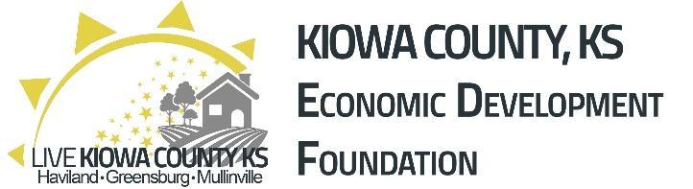
KIOWA COUNTY
Paint Program
Kiowa County Economic Development has established the Kiowa County Paint Program to assist in the purchase of paint and related supplies to improve commercial and/or residential properties within the County. KCED will allocate $5,000 per year in reimbursement grants to exterior paint projects of existing structures located within Kiowa County. Awards will reimburse up to $500.00 of paint and materials costs. Paint projects require a match of 50%. Grant applications are accepted until funds are exhausted and are available first come, first serve. Applicants must be current on all property tax. Renters may apply with owner permission. This is a reimbursement grant and funds will be dispersed upon proof of payment on completed projects. Only eligible improvements will be reimbursed.
PAINT PROGRAM OVERVIEW
Total funds allocated: $5,000
Max Award: $500.00
The mission of the Paint Program is to incentivize improvement of commercial properties. Our goal is to increase community pride and the appearance of county structures. This grant is for paint and paint supplies only. Labor is not eligible as a reimbursable expense.
GENERAL PROGRAM GUIDELINES
- Eligible applicants include property owners, tenants, and/or business owners within Kiowa County. Written approval by the property owner is required for all rental properties. Property must be located within Kiowa County.
- Applications for grants are available by email at livekiowacountyks@gmail.com.
- Applications will open January 1, 2023. All work must begin within 60 days of Notice to Proceed, and work must be completed by December 31, 2023.
- Applications are reviewed on a first come, first serve basis. Funds are awarded based on criteria set forth in the Application Process section located on page 4. The KCED is committed to funding projects throughout the County.
- Only one grant will be awarded for a single address within the County per calendar year. Only one property per owner/tenant will be eligible per calendar year.
- Applicants must be up to date on all city and county taxes (both 1st and 2nd half) and free from liens against the property.
- Applications will be screened and evaluated for awards by KCED.
- Each application must include “before” pictures showing the area(s) to be improved with the grant proceeds. Recipients must provide “after” pictures showing the improvements made prior to reimbursements being processed. The KCED may choose to use these pictures for program publicity on its online platforms.
- Cost estimates/bids will be required to be submitted with applications. Applications without proper documentation will be rejected. If a contractor is not being used, an itemized list of materials with pricing will suffice to give an overall estimate.
- Applications must include a completed W-9.
- Grants must be approved before proposed work begins in order to be eligible.
- Grants will be distributed after the work is completed and inspected by grantor. Grants will not be disbursed until work is compliant with codes and ordinances.
- Receipts/proof will be required to show the actual costs paid by the recipients for the materials used under the grant. No reimbursement will be given without such documentation. The grant amount paid will be based upon the verified proof/receipts, up to the amount listed in the initial grant award letter.
- When applicable, City permits will be required.
- The property owner will be responsible for appropriate disposal of debris, including debris from demolition and remodeling, and must show proof of proper and lawful disposal such as a landfill receipt, disposal service receipt, or burn permit. The debris is not to remain on the property once the project is completed.
- All federal, state, and local laws, codes, and ordinances must be followed for any work done under this program.
- These programs will only reimburse the material costs. Labor is not reimbursable.
- Work must begin within 60 days of Notice to Proceed.
- All work covered by these grants must be completed by December 31, 2023, which also includes any additional work needed to comply with city codes and ordinances. Grants will be forfeited for projects not completed by this deadline.
APPLICATION PROCESS
Step 1. Complete and submit a formal application including W-9. Submit application to Kiowa County Economic Development.
Step 2. Kiowa County Economic Development will review each application. Funding is limited. Applications may be denied, partially funded, or fully funded based on the availability of funds.
Step 3. After approval, the applicant will receive a “Notice to Proceed.” Work done before official notification will not be reimbursed. Work must begin within 60 days of notification and must conclude on or before December 31, 2023.
Step 4. After completion of work, submit all receipts, canceled checks, paid bills, and contractor lien waivers within 30 days to the KCED Director for reimbursement. Attach photos of completed work. A final inspection by KCED is required to ensure all work is completed.
Step 5. After project completion, paperwork submission, and grantor inspection funds will be made available to the applicant within 45 business days.
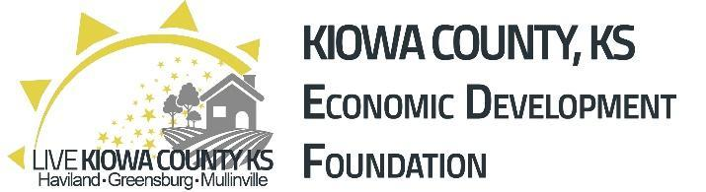
KIOWA COUNTY
FACADE PROGRAM
APPLICATION
ATTACH COPY OF W-9 WITH APPLICATION
PROPERTY INFORMATION
Property Address__________________________________________________________________________
__________________________________________________________________________
Is property currently for sale? _____________ Original Construction Date_____________________
Significant Historical or Architectural Information ______________________________________________
__________________________________________________________________________________________
APPLICANT INFORMATION
Applicant/Business Name __________________________________________________________________
Applicant Mailing Address _________________________________________________________________ _________________________________________________________________
Applicant Phone__________________________ Email___________________________________________ Years in Business_________________________ Number of Employees____________________________
PROPOSED IMPROVEMENTS (Attach estimates, design drawings, photographs, and supporting information) ______________________________________________________________________________
_________________________________________________________________________________________
If the contractor and/or retailer is not located in Kiowa County, please explain ____________________
_________________________________________________________________________________________
Estimated Cost _______________ Projected Start & Completion Date ___________________________
**Program requirements, eligibility, and funding amounts are subject to change.
Applicant Signature__________________________________ Date__________________________
PROPERTY OWNER INFORMATION & ACKNOWLEDGEMENT
Property Owner Name ____________________________________________________________________
Property Owner Address __________________________________________________________________
Property Owner Phone_______________________ Email________________________________________
I am the owner of the property noted in the property information section of this application. The contact information provided is accurate. I have been informed by the tenant of improvements described in this application and I authorize the tenant to apply for funds towards the completion of the improvements.
Property Owner Signature________________________________________ Date____________________

OFFICE USE ONLY
___________________ Completed Application (Pictures, Estimates, Forms)
___________________ Reviewed by code enforcement if applicable
___________________ Approved by Kiowa County Economic Development
___________________ Notice to proceed sent
___________________ Start Date (within 60 days of Notice to Proceed)
___________________ 60-Day Update
___________________ Completion Date (Before December 31, 2023)
___________________ Receipts & photos submitted (within 30 days of completion date)
___________________ Grantor inspection
___________________ Award Paid

